**Gradient Location and Orientation Histogram (GLOH)**

**Introduction to GLOH**

The **Gradient Location and Orientation Histogram (GLOH)** is an advanced image descriptor developed as an enhancement over the popular **SIFT (Scale-Invariant Feature Transform)**. It was introduced by Mikolajczyk and Schmid in 2005 to improve the robustness and distinctiveness of local image features used in tasks such as object recognition, image matching, and classification.

GLOH aims to capture not only the **gradient orientation** of keypoints but also their **spatial location** with a more informative binning strategy compared to SIFT. It incorporates spatial and orientation information by computing histograms in a log-polar location grid around each keypoint, making it more discriminative.

**How GLOH Works**

The GLOH descriptor consists of the following steps:

**a. Keypoint Detection**

Keypoints are first detected using a scale-invariant method. Typically, the Difference of Gaussians (DoG) detector, as used in SIFT, is employed to find stable and repeatable keypoints in the image.

**b. Patch Extraction**

Once a keypoint is identified, a local image patch around the keypoint (often 17×17 or 33×33 pixels) is extracted and normalized to account for rotation and scale changes.

**c. Log-Polar Grid Formation**

Instead of dividing the patch into a regular grid like in SIFT (e.g., 4×4 regions), GLOH uses a **log-polar grid**:

* 3 log-polar radii (concentric circles)
* 8 angular bins (sectors)
* 1 central region

This results in **17 spatial regions** (3 rings × 8 sectors + 1 center).

**d. Orientation Histogram Computation**

In each of the 17 spatial regions, a histogram of gradient orientations is computed using **16 orientation bins**. This gives a total of:

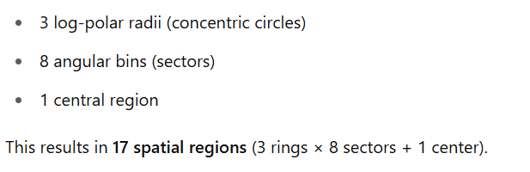

**e. PCA Dimensionality Reduction**

To reduce redundancy and dimensionality, **Principal Component Analysis (PCA)** is applied, reducing the 272-dimensional vector to a more compact 128-dimensional descriptor. This final vector is used for further processing like matching or classification.

**Comparison with SIFT**

| **Feature** | **SIFT** | **GLOH** |
| --- | --- | --- |
| Spatial Binning | Regular 4×4 grid | Log-polar grid |
| Orientation Bins | 8 | 16 |
| Dimensions | 128 | 272 (reduced to 128 with PCA) |
| Distinctiveness | Moderate | Higher due to fine spatial binning |
| Computational Cost | Lower | Higher |

**Advantages of GLOH over SIFT:**

* More descriptive due to finer orientation and spatial encoding.
* Improved performance in tasks like image classification and retrieval.

**Disadvantages:**

* Computationally more intensive.
* Requires PCA training data to project descriptors.

**Applications of GLOH**

GLOH has been successfully used in many computer vision tasks:

* **Object and Scene Recognition**: Its robustness to scale, rotation, and illumination makes it ideal for recognizing objects in varying conditions.
* **Image Classification**: When combined with classifiers like SVM or Random Forest, GLOH improves class separability.
* **Face Recognition**: Its rich local texture representation improves facial feature detection and matching.
* **Medical Imaging**: Used in texture-based analysis for classifying MRI or CT scan images.